- \(…)\Jogging single drive
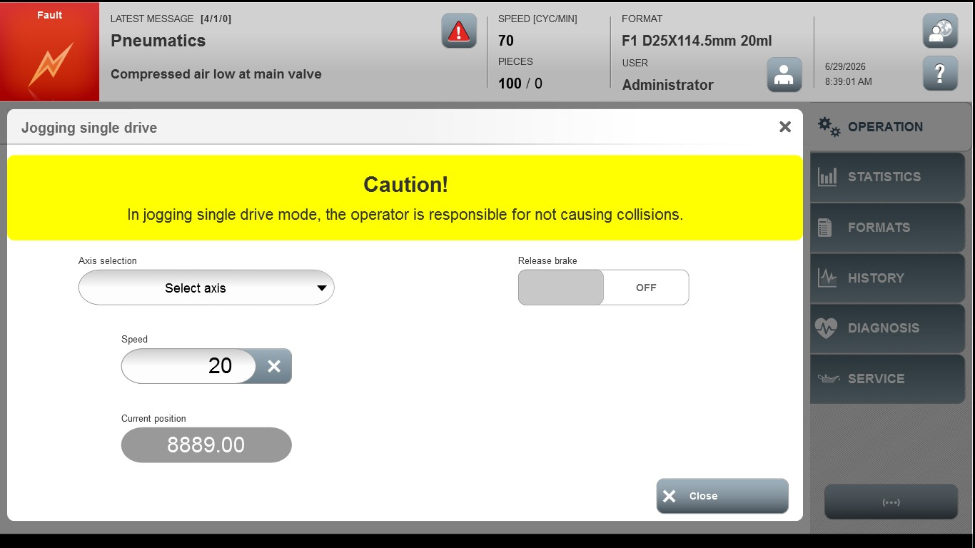
Acceptance criterion | Limits | Pass / Fail: Dev-No. | Date | Initials
Screen matches screenshot | N / A
Speed | 1..100

